Lab 7 – Static and Dynamic Routing Lab

1. Topology

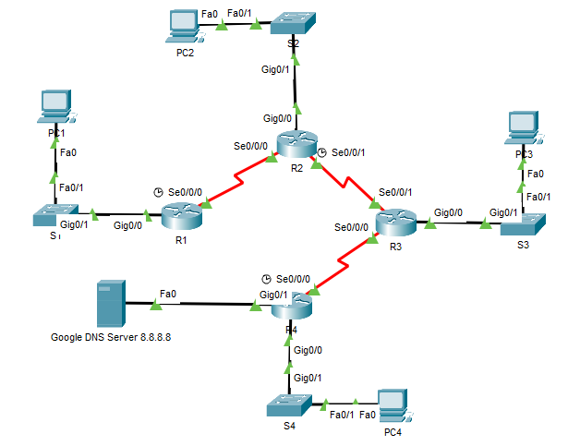

1. Addressing Table

|  |  |  |  |  |
| --- | --- | --- | --- | --- |
| Device | Interface | IPv4 Address | Subnet Mask | Default Gateway |
| R1 | G0/0 | 192.168.1.1 | 255.255.255.0 | N/A |
| S0/0/0 | 10.10.10.1 | 255.255.255.252 | N/A |
| R2 | G0/0 | 192.168.2.1 | 255.255.255.0 | N/A |
| S0/0/0 | 10.10.10.2 | 255.255.255.252 | N/A |
| S0/0/1 | 10.10.10.5 | 255.255.255.252 | N/A |
| R3 | G0/0 | 192.168.3.1 | 255.255.255.192 | N/A |
| S0/0/0 | 10.10.10.9 | 255.255.255.252 | N/A |
| S0/0/1 | 10.10.10.6 | 255.255.255.252 | N/A |
| R4 | G0/0 | 192.168.4.1 | 255.255.255.0 | N/A |
| G0/1 | 8.8.8.1 | 255.255.255.0 | N/A |
| S0/0/0 | 10.10.10.10 | 255.255.255.252 | N/A |
| PC1 | NIC | 192.168.1.2 | 255.255.255.0 | 192.168.1.1 |
| PC2 | NIC | 192.168.2.2 | 255.255.255.0 | 192.168.2.1 |
| PC3 | NIC | 192.168.3.2 | 255.255.255.0 | 192.168.3.1 |
| PC4 | NIC | 192.168.4.2 | 255.255.255.0 | 192.168.4.1 |

1. Configuring Static Routing
   * 1. Looking at the topology diagram, how many networks are there in total? _______8 networks______
     2. How many networks are directly connected to R1, R2, R3, and R4?

______________R1 – 2 networks, R2 – 3 networks, R3 – 3 networks, R4 – 3 networks___________________

* + 1. How many static routes are required by each router to reach networks that are not directly connected?

________R1- 6 routes, R2- 5routes , R3 – 5 routes

R4- 5 routes____________________________________________________________________________

* + 1. Test connectivity to the R2 and R3 LANs by pinging PC2 and PC3 from PC1.

Why were you unsuccessful? ____________Yes________________________________________________

1. Configure Static and Default Routes
   1. Configure static routes on R1.
      1. Configure a static route to every network not directly connected to R1, including the WAN link between R2 and R3.
      2. Test connectivity to the R2 LAN and ping the IP addresses of PC2 and PC3.

Why were you unsuccessful?

_____________________________Yes_______________________________________________________

* 1. Configure static routes on R2.
     1. Configure a static route from R2 to every network not directly connected.
     2. Which command only displays directly connected networks? __________do show ip route c_________________________
     3. Which command only displays the static routes listed in the routing table? ____________do show ip route static_____________
  2. Configure a default route on R3.
     1. How does a default route differ from a regular static route?

_________________________________It matches all packets that do not have a specific destination in the routing table and redirects the traffic to the next hop router or gateway. ___________________________________________________

____________________________________________________________________________________

____________________________________________________________________________________

* + 1. Configure a default route on R3 so that every network not directly connected is reachable.
    2. How is a static route displayed in the routing table? ________With an asterisk. _________________
  1. Configure a default route on R4.
     1. Configure a default route on R4 so that every network not directly connected is reachable.
  2. Verify static route configurations.

Use the appropriate **show** commands to verify correct configurations.

Which **show** commands can you use to verify that the static routes are configured correctly?

_________________________________________do show ip route _____________________________________

1. Verify Connectivity

Every device should now be able to ping every other device. If not, review your static and default route configurations.

1. Configure RIPv2
   1. Configure RIPv2 on R4.
      1. Use the appropriate command to create a default route on **R1** for all Internet traffic to exit the network through Gig 0/1.
      2. Enter RIP protocol configuration mode.
      3. Use version 2 of the RIP protocol and disable the summarization of networks.
      4. Configure RIP for the networks that connect to **R4**.
      5. Advertise the default route configured in step 1a with other RIP routers.
      6. Save the configuration.
   2. Configure RIPv2 on all other routers.
2. Verify Configurations
   1. View routing tables of R1, R2, R3, and R4.
      1. Use the appropriate command to show the routing table of **R1**. RIP (R) now appears with connected (C) and local (L) routes in the routing table. All networks have an entry. You also see a default route listed.
      2. View the routing tables for **R2** and **R3**. Notice that each router has a full listing of all the 192.168.x.0 networks and a default route.
   2. Verify full connectivity to all destinations.

Every device should now be able to ping every other device inside the network. In addition, all devices should be able to ping the **Web Server**.